Project Title : Strategic product placement analysis
(unveiling sales impact with tableau visualization)

Team ID : LTVIP2026TMIDS55906
Team Leader : Chenna Priyanka
Team Member : G Sailaja
Team Member : Esambadi Pavan Kalyan
Team Member : G Kalyani

1.INTRODUTION :
1.1 Project Overview :
The project “Strategic Product Placement Analysis: Unveiling Sales Impact with Tableau Visualization” focuses on analyzing how the positioning of products within a retail store affects customer purchasing behavior and overall sales performance. Using interactive Tableau dashboards, the project visualizes sales trends, product visibility patterns, and placement effectiveness across different store zones.
By transforming raw sales data into insightful visual representations, the project enables retailers to understand which product placements drive higher engagement, better conversions, and improved revenue. This data-driven approach helps optimize store layouts and enhances strategic decision-making.
1.2 Purpose of the Project:
The primary purpose of this project is to evaluate and enhance the effectiveness of product placement strategies through data visualization and analytics. The project aims to:
- Identify how shelf position, aisle location, and promotional zones influence sales.
- Provide retailers with actionable insights to optimize product layouts.
- Improve customer buying experience by placing high-demand products more strategically.
- Support data-driven decision-making for maximizing sales, reducing operational inefficiencies, and improving store performance.
Overall, the project serves as a decision-support tool that empowers businesses to refine their merchandising strategies and achieve measurable sales improvements.
2.IDEATION PHASE :
2.1 Problem Statement :
Retailers often lack clear insights into how product placement inside a store influences customer purchases and overall sales. Traditional sales reports show numbers but do not reveal how shelf position, aisle location, or promotional zones affect product performance.
This gap leads to ineffective store layouts and missed opportunities to boost sales.
The project aims to solve this problem by using Tableau visualizations to analyze sales data and identify patterns related to product placement. The insights help retailers make better merchandising decisions and improve product visibility to maximize sales impact.
Problem Statement (PS) | I am (Customer) | I’m trying to | But | Because | Which makes me feel
PS-1 | A retail store manager. | Understand which product placements increase sales. | I can’t identify which shelf or zone performs best. | Sales data is not clearly visualized. | Confused and unable to make effective placement decisions.
PS-2 | A retail business owner. | Improve product visibility and sales. | I don’t know which locations impact customer buying. | There is no dashboard showing placement-based sales insights. | Frustrated and limited in planning store layout.
2.2 Empathy map Canvas :
The Empathy Map Canvas captures the needs and expectations of retail managers and data analysts who seek better clarity on how product placement impacts sales. They believe that visual dashboards can simplify complex sales data and provide meaningful insights into customer buying behavior. Currently, they rely on traditional sales reports and manual analysis, which often fail to reveal placement-related patterns.
This lack of clarity creates frustration and uncertainty when making layout or merchandising decisions. The canvas highlights the need for simple, visual, and actionable insights that help stakeholders optimize product placement, enhance customer engagement, and ultimately improve overall sales performance.
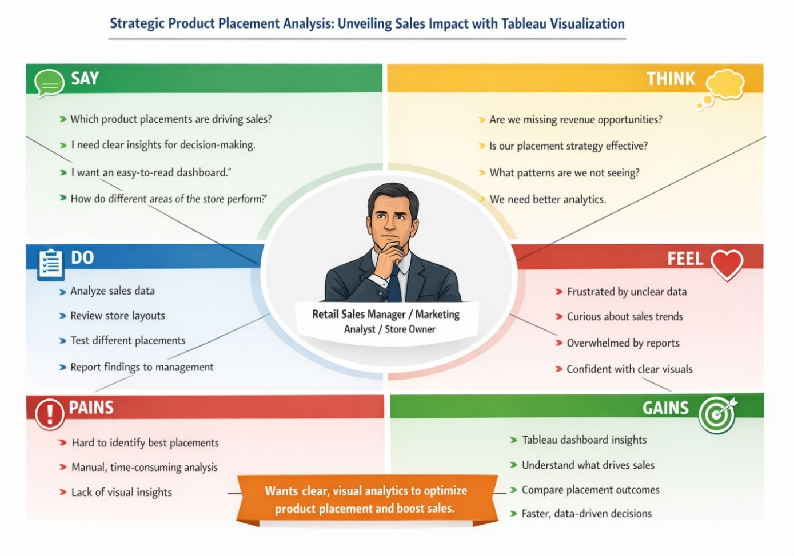

2.3 Brainstorming :
Brainstorming provides a free and open environment that encourages everyone within a team to participate in the creative thinking process that leads to problem solving. Prioritizing volume over value, out-of-the-box ideas are welcome and built upon, and all participants are encouraged to collaborate, helping each other develop a rich amount of creative solutions.
Use this template in your own brainstorming sessions so your team can unleash their imagination and start shaping concepts even if you're not sitting in the same room.
Step-1: Team Gathering, Collaboration and Select the Problem Statement
Our team collaborated virtually and reviewed the WHC Sites 2019 dataset. After thorough discussion, we selected the problem statement:
“To analyze and visualize the global distribution, area, and danger status of UNESCO World Heritage Sites using Tableau for insightful storytelling.”

Step-2: Brainstorm, Idea Listing and Grouping
Brainstorming provides a free and open environment that encourages everyone within a team to participate in the creative thinking process that leads to problem solving. Prioritizing volume over value, out-of-the-box ideas are welcome and built upon, and all participants are encouraged to collaborate, helping each other develop a rich amount of creative solutions.
Use this template in your own brainstorming sessions so your team can unleash their imagination and start shaping concepts even if you're not sitting in the same room.
Reference: https://www.mural.co/templates/brainstorm-and-idea-prioritization
Step-1: Team Gathering, Collaboration and Select the Problem Statement :
Problem Statement Selected:
Retail and e-commerce businesses often struggle to understand how the placement of products within stores or on digital storefronts influences sales performance. Without proper analytics, decisions around shelf placement, category grouping, and promotional positioning remain guess-based rather than data-driven.
Objective of the Project:
To analyze product placement strategies and identify which shelf positions, zones, or display layouts lead to maximum sales. The project aims to deliver a Tableau-based interactive dashboard to visualize patterns, trends, and high-performing product positions.
Key Discussion Points During Team Collaboration:
- Many retailers fail to measure placement impact despite collecting sales data.
- Understanding placement effectiveness can boost revenue significantly.
- Visualization using Tableau can make insights more interactive and decision-friendly.
- Project can create real-world value for retail domains, supermarkets, and online platforms.
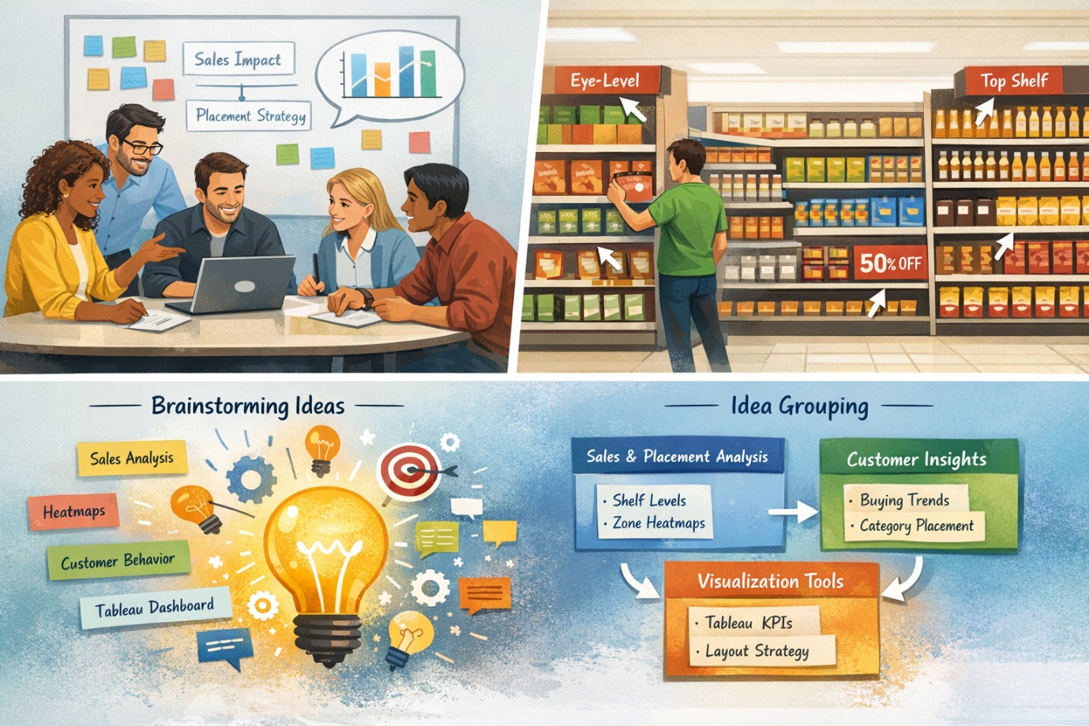

Step-2: Brainstorm, Idea Listing and Grouping :
Raw Ideas Generated:
- Analyze sales trends based on shelf levels (top, eye-level, bottom).
- Compare sales between end-cap displays vs normal shelves.
- Identify customer buying patterns influenced by product adjacency.
- Visualize heatmaps showing high-selling store zones.
- Determine correlation between product category placement and sales lift.
- Integrate promotional placement impact (discount vs location).
- Suggest optimal product arrangement for maximum visibility.
- Build an interactive Tableau dashboard for real-time visualization.
- Use KPIs like conversion rate, sales uplift, customer footfall patterns.
- Recommend model for ideal store layout using insights.
Grouped Ideas
Group A – Sales & Placement Analysis
- Shelf-level sales evaluation
- Zone-based heatmaps
- End-cap vs regular shelf comparison
- Product adjacency impact analysis
Group B – Customer Behavior Insights
- Buying trend visualization
- Category-wise placement effectiveness
- Seasonal impact on placement
Group C – Visualization & Decision Tools
- Tableau dashboards
- Key metrics and KPIs
- Recommended layout strategies
- Interactive filters for store managers
Step-3: Idea Prioritization :
Prioritization Criteria Used:
- Feasibility
- Data availability
- Value creation for retailers
- Ease of visualization in Tableau
- Impact on decision-making
Final Prioritized Solution:
The team will focus on creating a comprehensive Tableau dashboard that reveals the impact of product placement on sales using:
- Shelf-level performance charts
- Zone heatmaps
- End-cap effectiveness analysis
- Category & adjacency insights
- KPIs for quick decision-making
The goal is to deliver an actionable visualization system enabling businesses to optimize product placement and maximize sales.

3.REQUIREMENT ANALYSIS :
  - Customer Journey Map :
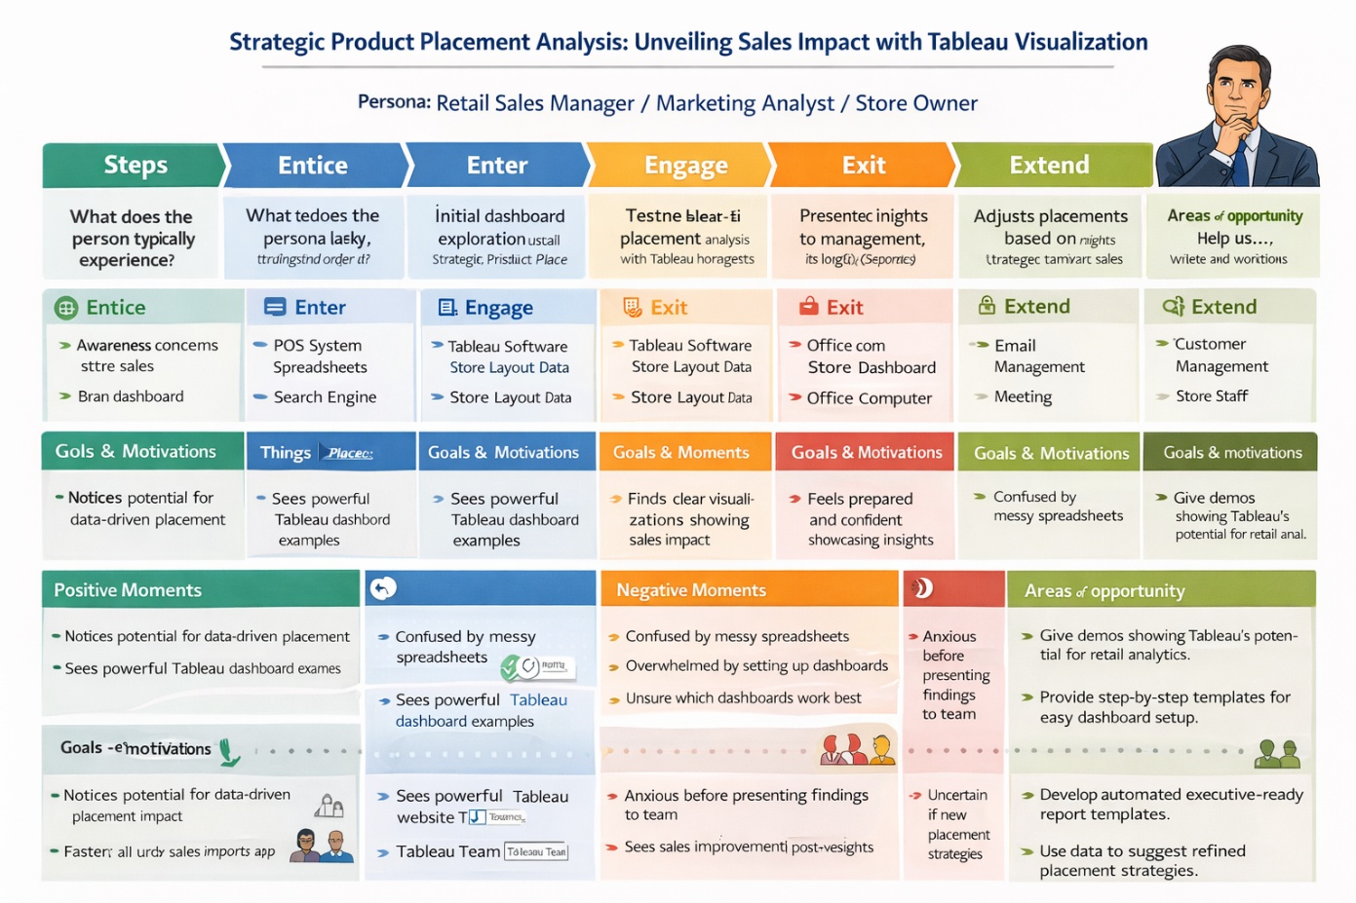
  - Solution Requirement :
Functional Requirements:
Following are the functional requirements of the proposed solution.
FR No. | Functional Requirement (Epic) | Sub Requirement (Story / Sub-Task)
FR-1 | Data Import & Integration | Import sales data (CSV/Excel)  Connect to POS system data  Import store layout / planogram data
FR-2 | Data Processing & Cleaning | Handle missing values, duplicates  Standardize product/category fields  Map product IDs to shelf positions
FR-3 | Dashboard Visualization | Sales performance visualization charts  Product placement heatmaps  Before/After placement comparison  Interactive filters (time, product, zone)
FR-4 | Insights & Reporting | Automated insights on top-performing zones  Generate summary reports  Export dashboard insights as PDF
FR-5 | User Access & Sharing | Publish dashboard on Tableau Public  Share access links with stakeholders  Role-based viewing permissions

Non-functional Requirements:
Following are the non-functional requirements of the proposed solution.
FR No. | Non-Functional Requirement | Description
NFR-1 | Usability | - Dashboard should be simple, intuitive, and easy for retail managers to understand.
NFR-2 | Reliability | System must load data and visuals accurately  without errors or corruption.
NFR-3 | Performance | - Dashboard must load within 3–5 seconds even with large datasets.
NFR-4 | Scalability | Supports increasing data size and additional  store locations without performance loss.

  - Data Flow Diagram :
The Data Flow Diagram (DFD) for the project “Strategic Product Placement Analysis: Unveiling Sales Impact with Tableau Visualization” represents how sales data moves through the system to produce meaningful insights.
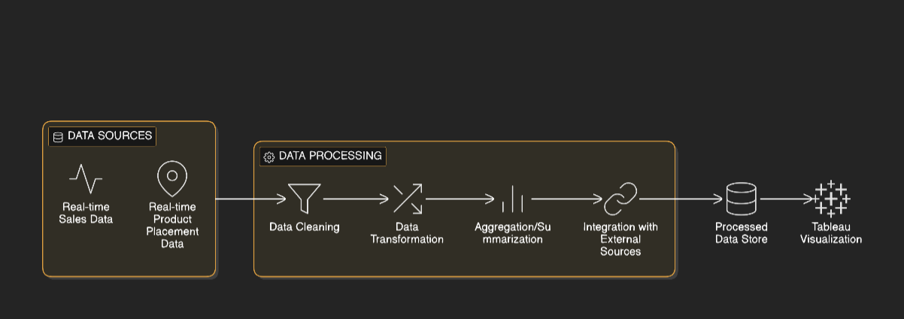
  - Technology Stack :
The project “Strategic Product Placement Analysis: Unveiling Sales Impact with Tableau Visualization” uses a streamlined technology stack to collect, process, analyze, and visualize sales data for better product placement decisions.
1. Data Source
Excel / CSV Files – Used to store sales data, product details, and placement information.
2. Data Processing
Python (Pandas, NumPy) – Cleans, preprocesses, and prepares the datasets for analysis.
Jupyter Notebook / VS Code – Environment used to run data analysis scripts.
3. Data Visualization
Tableau Public / Tableau Desktop – Core visualization tool used to build dashboards, heatmaps, KPIs, and sales impact visualizations.
4. Supporting Tools
MS Excel – Initial data formatting and quick calculations.
GitHub / Cloud Storage – Storing project files, documentation, and datasets.
5. Deployment / Sharing
Tableau Public Link / Web Embed – Used to share the final interactive dashboard with stakeholders.
- PROJECT DESIGN :
  - Problem Solution Fit :
Retail businesses often struggle to understand how product placement inside the store impacts sales, because sales reports are scattered, layout data is not visual, and insights are not clear.
This project provides a Tableau-based visualization system that combines sales data with store layout to reveal which product placements drive the highest sales, enabling data-driven decisions to optimize store performance.
Purpose:
- Identify the store zones and shelf positions that increase sales.
- Visualize sales and placement data through interactive Tableau dashboards.
- Compare product performance before and after placement changes.
- Enable data-driven decision-making for retail managers and analysts.

Template:
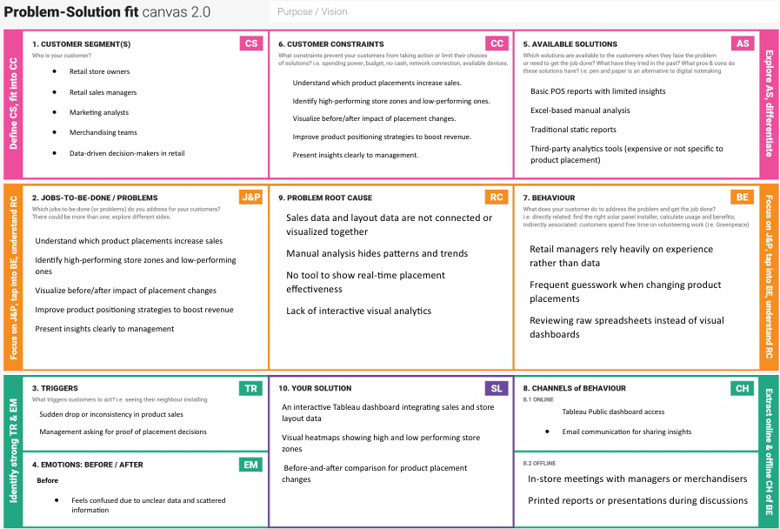
References:
1. https://www.ideahackers.network/problem-solution-fit-canvas/ https://medium.com/@epicantus/problem-solution-fit-canvas-aa3dd59cb4fe
  - Proposed Solution :
The proposed solution for “Strategic Product Placement Analysis: Unveiling Sales Impact with Tableau Visualization” is a data-driven analytical system that identifies how product placement influences sales performance. The solution uses structured data analysis and interactive visual dashboards to help retailers make smarter decisions.
S.No. | Parameter | Description
 | Problem Statement (Problem to be solved) | Retailers struggle to understand how product placement affects sales due to scattered and non-visual data.
 | Idea / Solution description | A Tableau-based interactive dashboard that visualizes the impact of product placement on sales performance.
 | Novelty / Uniqueness | It uniquely integrates store layout and sales data to reveal real-time placement effectiveness through visual analytics.
 | Social Impact / Customer Satisfaction | Enhances shopping experience and sales efficiency by ensuring products are placed where customers find them easily.
 | Business Model (Revenue Model) | Revenue can be generated through subscription-based analytics dashboards and customized retail insights services
 | Scalability of the Solution | The system can easily scale across multiple stores, larger datasets, and additional product categories.

  - Solution Architecture :
Solution architecture is a complex process – with many sub-processes – that bridges the gap between business problems and technology solutions. Its goals are to:
- Integrate sales and store layout data into a unified analytical system.
- Use Tableau dashboards to visually analyze product placement effectiveness.
- Provide interactive filters and comparison views to evaluate before–after placement impact.
- Generate automated insights and reports to support data-driven decision-making.

Example - Solution Architecture Diagram:

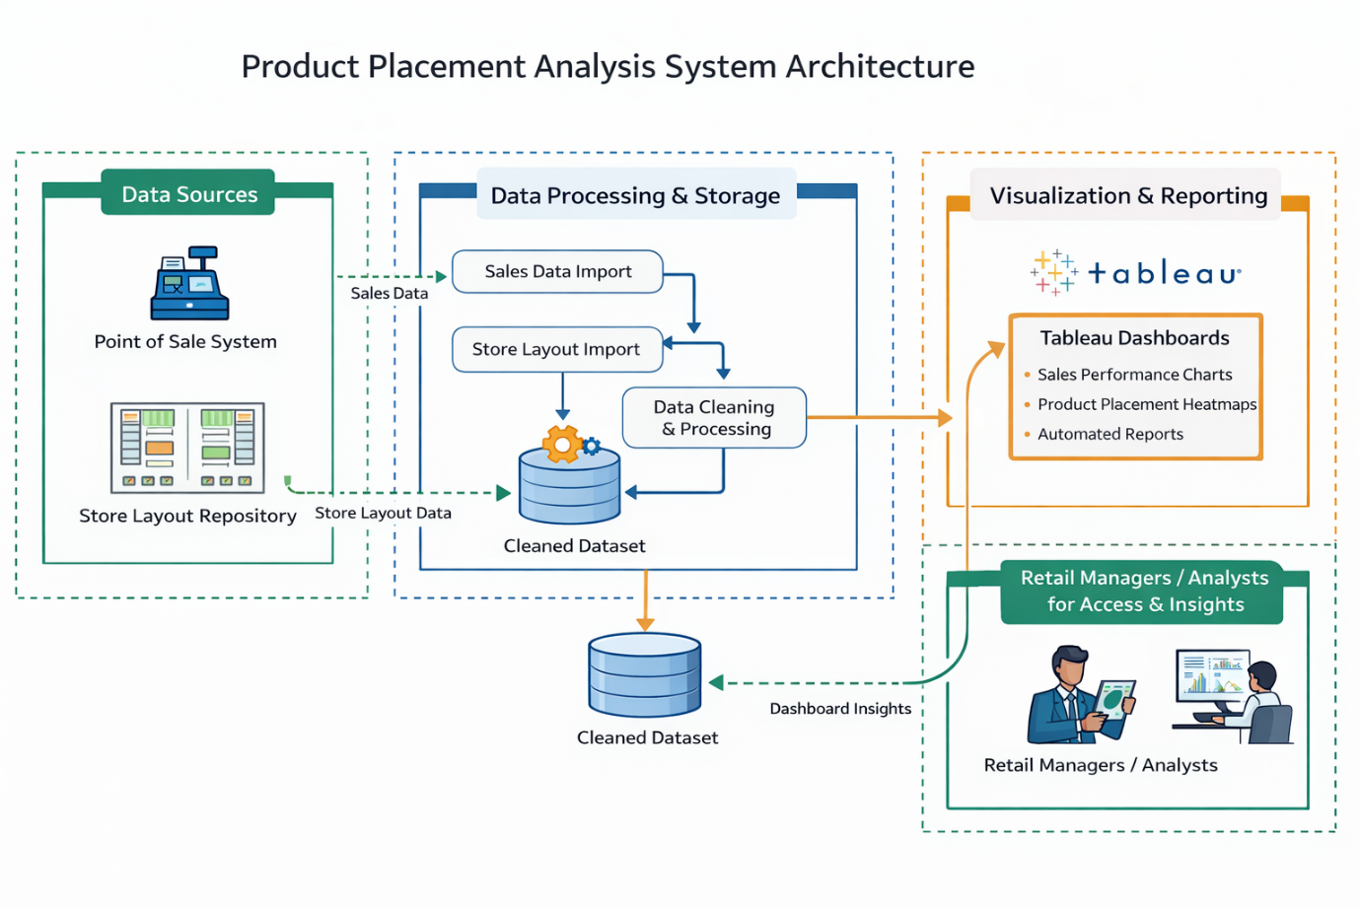
Figure 1: Architecture and data flow of the voice patient diary sample application
Reference: https://aws.amazon.com/blogs/industries/voice-applications-in-clinicalresearch-powered-by-ai-on-aws-part-1-architecture-and-design-considerations/
- PROJECT PLANNING & SCHEDULING :
  - Project Planning :
    - Planning Logic :
Project Title: Strategic Product Placement Analysis
Epic: Unveiling Sales Impact with Tableau Visualization
This epic is too large to complete in one sprint and will be broken down into smaller tasks over multiple sprints.
Sprint 1: Data Acquisition & Preparation (5 Days)
      - Story: Data Collection o Collecting UNESCO World Heritage Site data: 2 Story Points (Very Easy task) o Loading data into a suitable format: 1 Story Point (Very Easy task)
      - Story: Data Preprocessing o Handling missing values in the dataset: 3 Story Points (Moderate task) o Handling categorical values (e.g., criteria, types): 2 Story Points (Easy task)
Sprint 2: Tableau Development & Deployment (5 Days)
      - Story: Dashboard Building
        - Designing and building interactive Tableau dashboards: 5 Story Points (Difficult task) o Testing and refining dashboard functionality: 3 Story Points (Moderate task)
      - Story: Deployment & Presentation
        - Preparing Tableau workbook for sharing/embedding: 3 Story Points
(Moderate task)
        - Documenting insights and findings for presentation: 5 Story Points (Difficult task)
Velocity Calculation:
      - Total Story Points (Sprint 1): 2 + 1 + 3 + 2 = 8 Story Points
      - Total Story Points (Sprint 2): 5 + 3 + 3 + 5 = 16 Story Points
      - Total Story Points Completed: 8 + 16 = 24 Story Points
      - Number of Sprints: 2
      - Velocity: Total Story Points Completed / Number of Sprints = 24 / 2 = 12 Story Points per Sprint
Your team’s velocity is 12 Story Points per Sprint.
    - Project Planning :
The project planning for Strategic Product Placement Analysis begins with identifying business objectives and understanding the retailer’s need to determine how product placement influences overall sales performance. The planning process includes collecting relevant datasets such as sales history, product details, and placement zone information. These datasets are examined for completeness and prepared through data cleaning, formatting, and standardization using tools like Python and Excel to ensure accuracy before analysis.
After preparing the data, the project progresses into the analytical and visualization phase. Here, patterns, correlations, and key performance indicators (KPIs) related to placement effectiveness are defined. A visualization plan is created to outline the charts, heatmaps, KPIs, and comparisons required for the dashboard. Tableau is then used to build interactive dashboards that help users explore product placement impacts, category trends, and store-level variations through filters and intuitive layouts.
Finally, the planning includes testing outputs, validating dashboard results with the processed dataset, and refining visual designs based on feedback. Once complete, the dashboard is published through Tableau Public for easy access and sharing. The project concludes with compiling insights and actionable recommendations for retailers, ensuring the findings can directly support strategic decision-making and layout optimization.
6.FUNCTIONAL AND PERFORMANCE TESTING :
6.1 Performance Testing :
Functional testing for the project ensures that every component of the product placement analysis system works as intended. This includes validating whether the cleaned datasets load correctly into Tableau, checking that filters (such as category, product, store, or date) respond accurately, and verifying that each visualization—heatmaps, bar charts, KPIs, trend lines—displays the correct data. Functional testing also focuses on ensuring the user can interact with the dashboard smoothly, such as drilling down into specific categories or switching between comparison views without errors or broken visuals.
Performance testing focuses on the efficiency, speed, and stability of the dashboard under different conditions. This involves measuring how quickly Tableau renders visualizations when applying filters or loading large datasets. It also checks for delays or lag when switching between dashboard pages or interacting with multiple charts. The goal is to ensure that the dashboard loads quickly, handles large sales datasets efficiently, and maintains consistent responsiveness for end-users.
Together, functional and performance testing verify that the analytical system not only works correctly but also performs reliably under practical usage scenarios, ensuring smooth decision-making and a high-quality user experience for stakeholders.

- RESULTS :
  - Output Screenshots :

Fig 1 : Avg. Sales Volume by Category
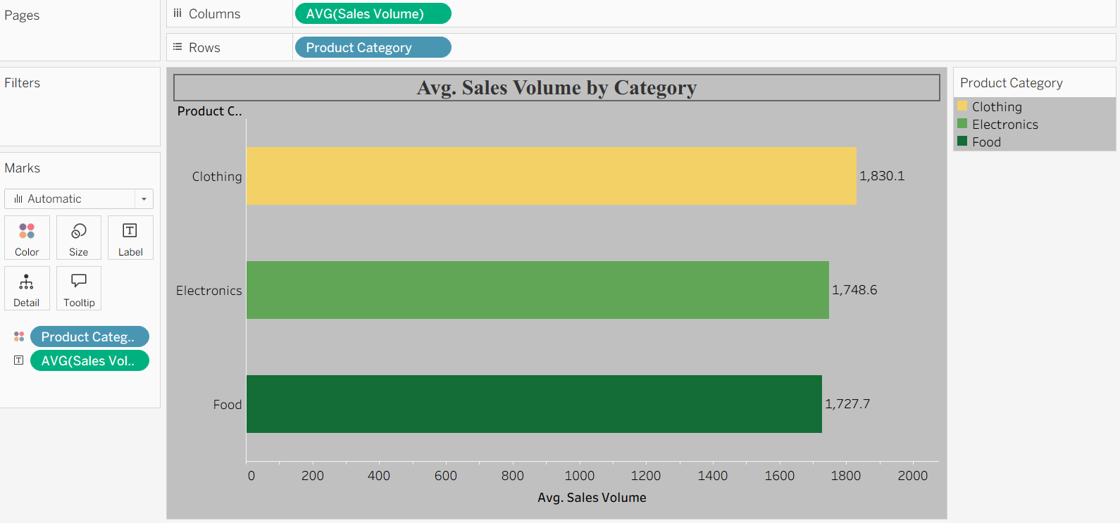

Fig 2 : Competitor Price VS Price
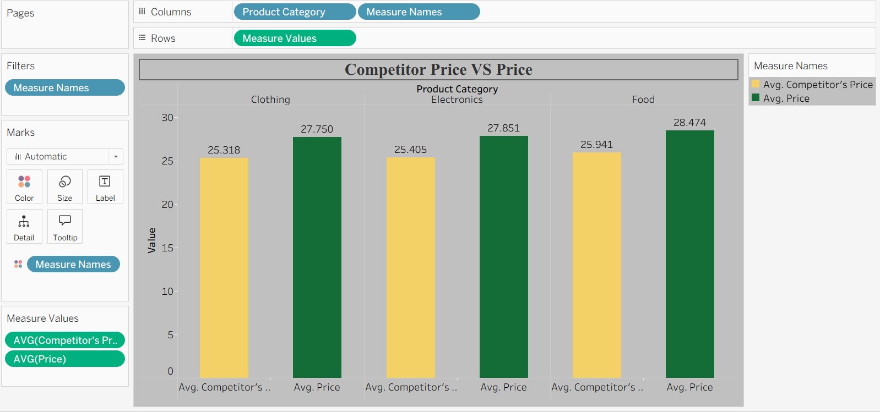

Fig 3 : Avg Sales Volume by Product Category by Product Position

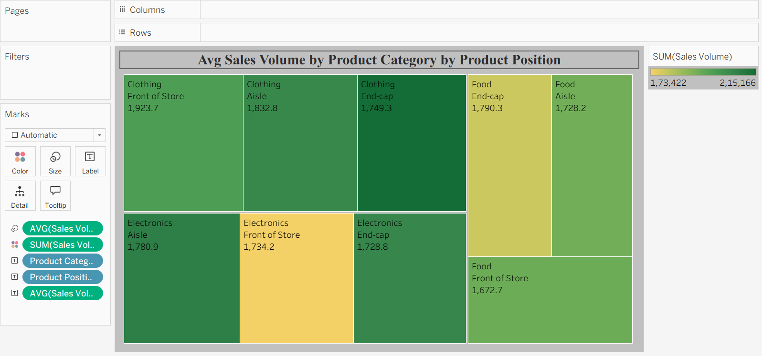

Fig 4 : Consumer Demographics vs Sales Volume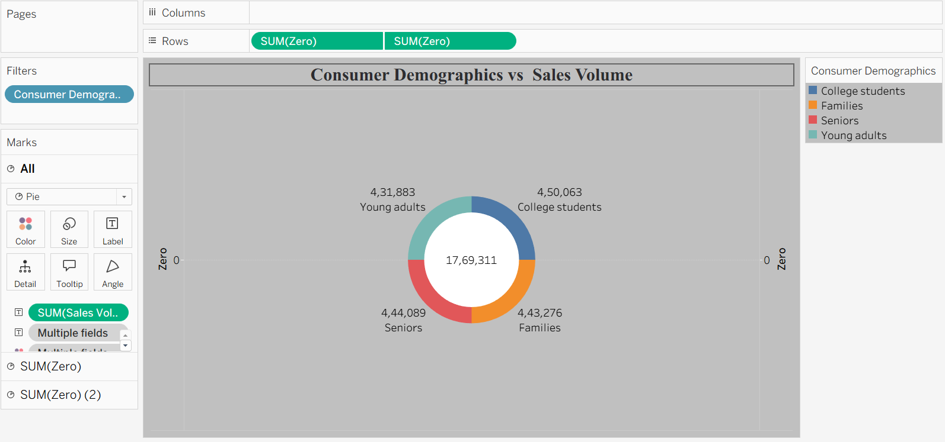

Fig 5 : Product Category vs Price 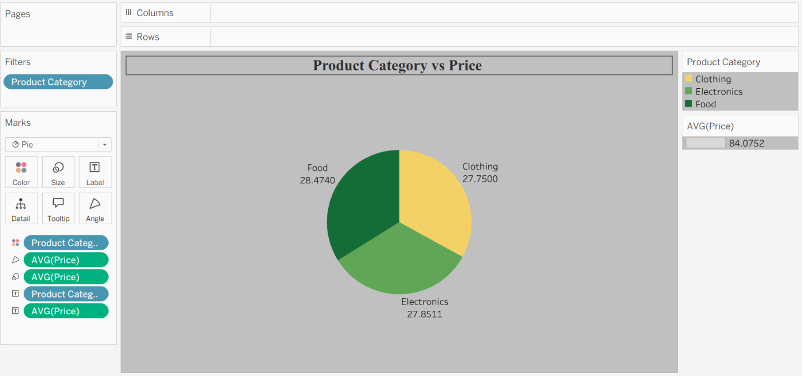

Fig 6 : Avg. Sales Volume by Product Category by Season
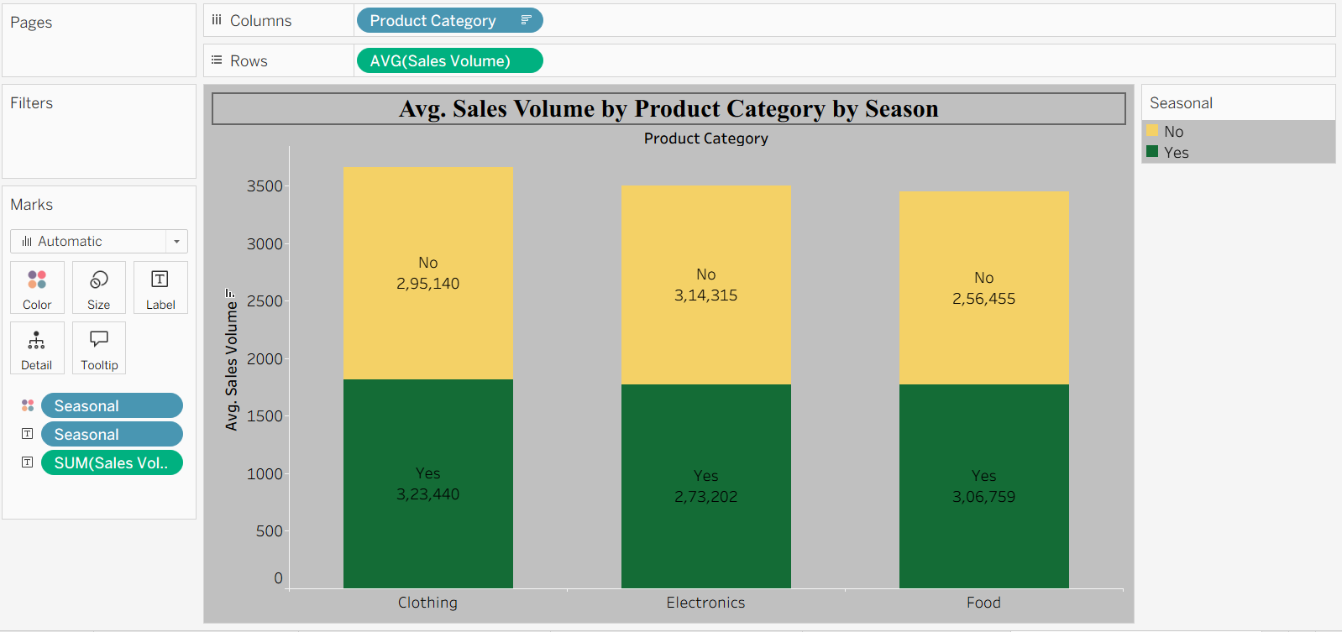

Fig 7 : Foot Traffic by Avg Sales Volume
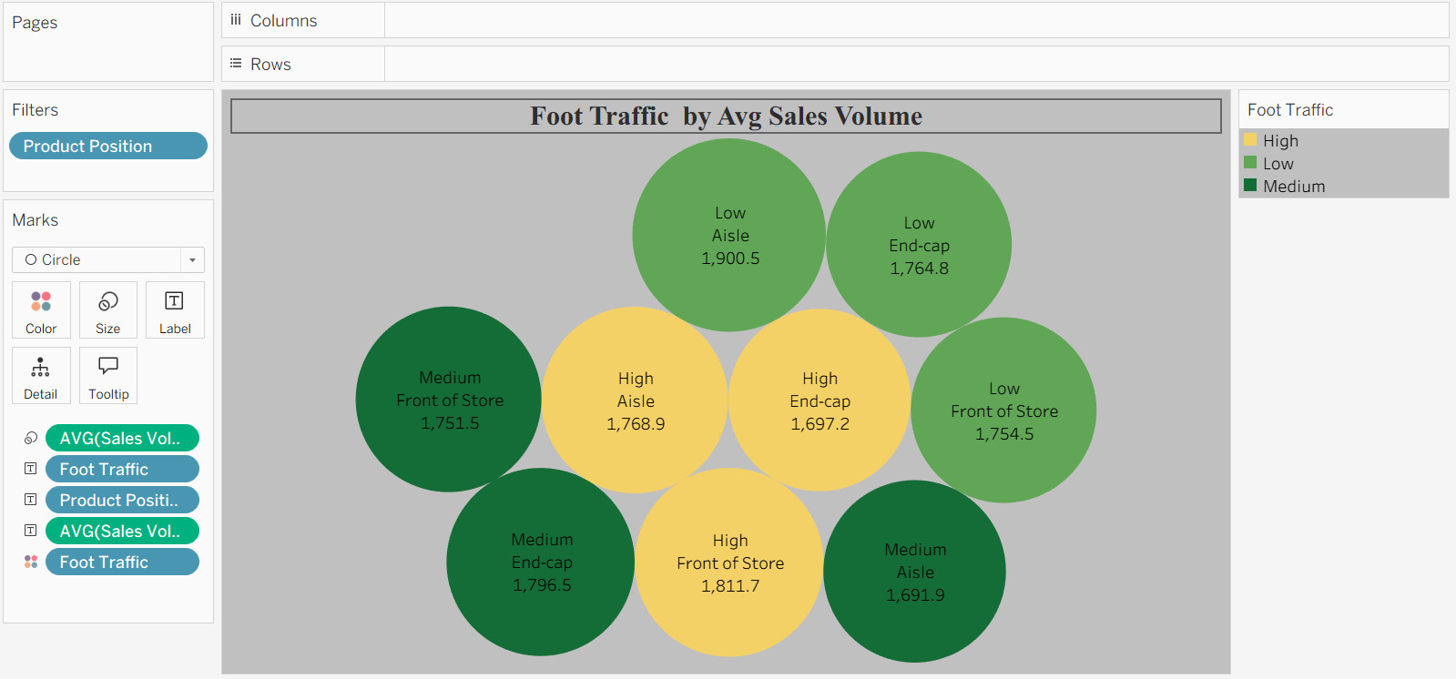

Fig 8 : Promotion of Product Category on Price and Sales Volume
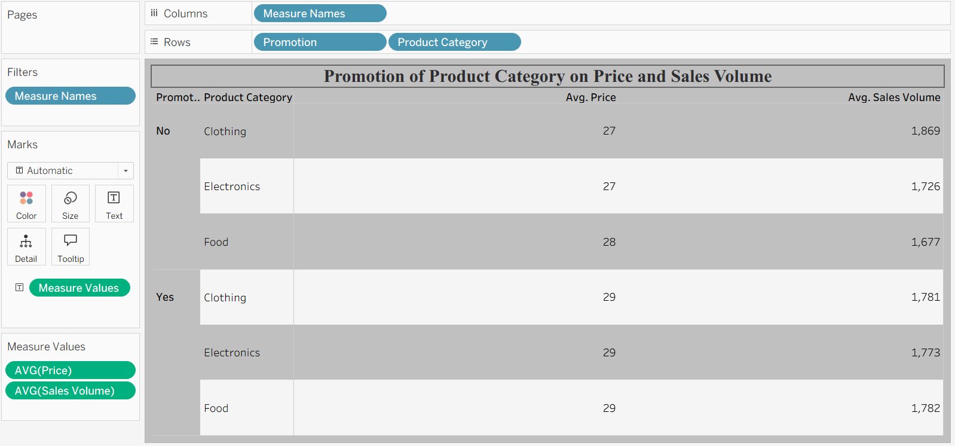

  - Dashboard Screenshots :
Dashboard 1
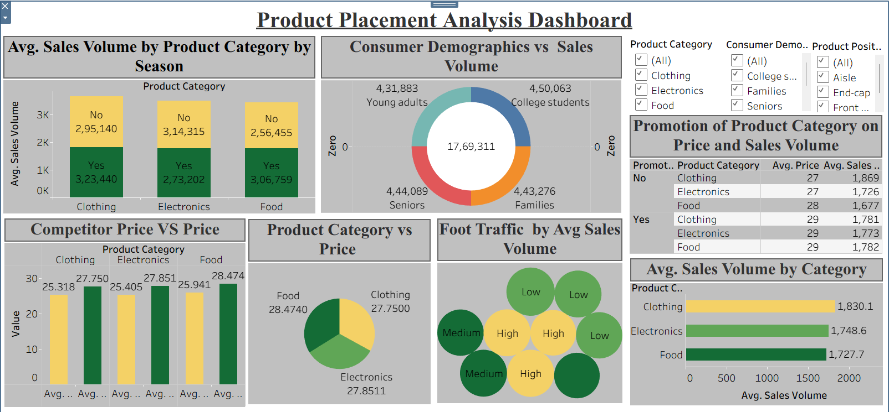

8.Advantages and Disadvantages :
Advantages :
- Data-Driven Decision Making
Retailers can make accurate placement decisions based on real sales patterns rather than assumptions.
- Improved Sales Performance
Identifies high-impact zones/shelves that maximize product visibility and increase revenue.
- Interactive Visual Insights
Tableau dashboards provide user-friendly, real-time filtering and interactive analysis.
- Quick Identification of Trends
Helps detect seasonal trends, category performance, and placement-based behavior instantly.
- Enhanced Store Layout Optimization
Supports optimizing shelf arrangements and store layouts for better customer engagement.
- Better Resource Allocation
Helps retailers focus on high-performing products and zones, saving time and effort.
- Easy Sharing & Accessibility
Dashboards published via Tableau Public can be accessed anywhere without complex software installation.

Disadvantages :
- Dependent on Data Quality
Poor or incomplete sales/placement data can lead to inaccurate insights.
- No Predictive Modeling
Tableau visualizes current trends but cannot predict future placement performance without additional ML models.
- Limited Custom Logic in Tableau
Complex statistical operations cannot be directly implemented within Tableau alone.
- Requires Skilled Users
Non-technical users may struggle with interacting with filters and advanced dashboard features.
- Performance Issues With Large Data
Very large datasets may cause slow dashboard loading or lag in interactions.
- Static Placement Categories
If placement zones change frequently, visualizations require regular updates.
- Not Fully Automated
Data preprocessing, cleaning, and updates often require manual intervention.
9.Conclusion :
The project Strategic Product Placement Analysis: Unveiling Sales Impact with Tableau Visualization successfully demonstrates how data-driven insights can significantly enhance retail decision-making. By integrating sales data, product information, and placement details, the system provides a clear understanding of how product positioning influences customer purchasing behavior. Through structured data preprocessing and analytical planning, the project transforms raw data into meaningful and actionable insights.
The interactive Tableau dashboard developed in the project plays a crucial role in visualizing placement effectiveness, category-wise performance, and sales trends. Its dynamic filters, heatmaps, KPIs, and comparison charts enable users to explore data intuitively and uncover hidden patterns that traditional reporting methods often overlook. This real-time visualization capability empowers store managers, analysts, and decision-makers to identify high-performing zones and optimize store layouts efficiently.
Overall, the project highlights the value of combining structured analytics with advanced visualization tools to support strategic retail planning. The insights generated not only help in improving product placement strategies but also contribute to enhanced customer engagement and increased revenue potential. With further enhancements such as predictive modeling and automated data updates, this system can evolve into a comprehensive decision-support platform for modern retail environments.

10.Future Scope :
The project has strong potential for expansion through advanced analytics and automation. One major future enhancement is the integration of predictive modeling and machine learning algorithms to forecast sales performance based on different product placement scenarios. This would allow retailers to simulate layout changes before implementation and choose the best arrangement for maximum sales impact.
Another important future direction is the development of a real-time data pipeline. Automating data collection from POS systems and integrating it directly with Tableau dashboards would ensure that insights are always up-to-date without manual intervention. This enables continuous monitoring of product placement effectiveness and faster response to market changes.
Additionally, the system can be extended to include customer behavior analytics, such as footfall heatmaps or in-store navigation patterns, by integrating IoT sensors or camera analytics. Expanding the dashboards to support multi-store comparison, automated report generation, and mobile-friendly visualization will further improve usability and make the tool a robust decision-support system for large-scale retail operations.

11.Appendix :
Dataset Link :-
- https://www.kaggle.com/datasets/amitvkulkarni/impact-of-product-positioning-on-sales
Git Hub Link :-
- https://github.com/Pavankalyan-12395/Strategic-Product-Placement-Analysis.git

Tableau File Link :-
- https://public.tableau.com/views/ProductPlacementAnalysisProject/Story1?:language=enUS&:sid=&:redirect=auth&:display_count=n&:origin=viz_share_link
Web Integration Video Link :
- https://drive.google.com/file/d/1yR63ZAW2SMhkT9T5diqr6Mu6QV5TSIFe/view?usp=sharing

